Chapter 15, Problem 39.

Determine f(t) if:

(a) 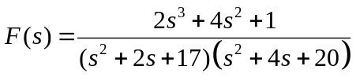
(b) 